BAHRIA MODEL COLLEGE E-8 ISLAMABAD
NOTE: submit your assignment at
Gmail= ramistacademia@gmail.com
NAME:
CLASS:
SUBJECT:
ASSIGNMENT NO 1
TOPIC: ATOM & MOLECULE
SUBMITTED TO: (name of teacher)
DUE DATE: 12. JUNE

QNO1: make a cards to answer the following questions.
- What is the smallest part of matter?
- What is an atom?
- What are the three main parts of an atom?
- Where are these parts located in an atom?
QNO2: Using the Bohr Model Template, and three different colors (papers, marker color, pencil colors) have students make structure of these atoms. Assign a code for protons, neutrons, and electrons.
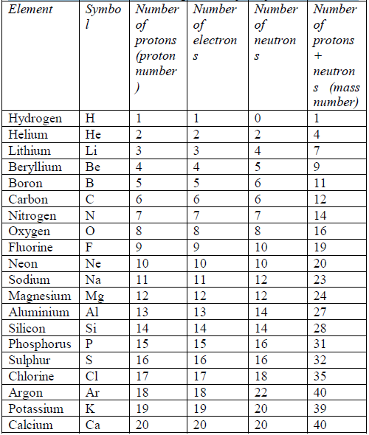

Hints: for making atom:
Take 3 different color papers
For proton= orange
For neutron = light blue
For electron= red
e.g if u want to make an helium atom
1. look at the table given above and collect information about helium atom.
2. symbol = He
No of proton= 2
No 0f neutron= 2
No of elecctron= 2
3. Then make an atom

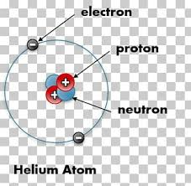
Ramistacademia@gmail.com

